Project 4: TinyML

TA: Giuseppe Averta, Niccolò Cavagnero, Shyam Nandan Rai

**OVERVIEW**

The deployment of Deep Neural Networks (DNNs) on resource-constrained devices is a critical challenge in the field of machine learning and deep learning. In response, TinyML has emerged as a field that focuses on the deployment of DNNs on small and efficient devices such as wearables, sensors and IoT devices.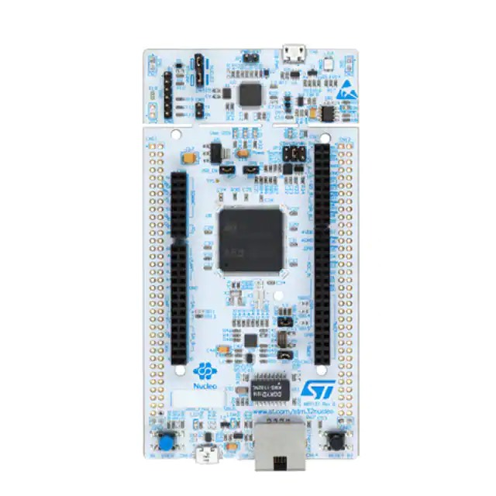

TinyML has numerous potential applications across a range of industries. Smart sensors

that can detect anomalies and optimize energy usage, wearable devices that can monitor health metrics, autonomous systems like drones and self-driving cars, edge computing to process data closer to the source, industrial automation for predictive maintenance, and environmental monitoring for air and water quality are just a few examples. As the field of Tiny Machine Learning continues to grow, we can expect to see even more innovative and intelligent devices that can process data locally without relying on cloud computing or high-powered servers.

While Tiny Machine Learning is a field with much promise, it also faces several challenges which include developing accurate and efficient models on devices with limited memory and processing power, working with small datasets, minimizing energy consumption, requiring low latency.. The main objective of these projects is to implement a DNN for a computer vision task that could be deployed on a resource constrained device.

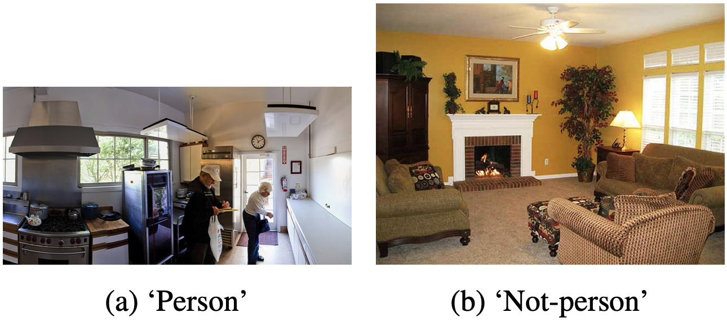

**Project 4A** (TA: Niccolò Cavagnero): **Neural Architecture Search for Visual Wake Words**

In this project the goal is to implement a Tiny Neural Network to perform Visual Wake Words task on a tiny device for the purpose of detecting individual. Neural Architecture Search techniques will be exploited to design the networks.

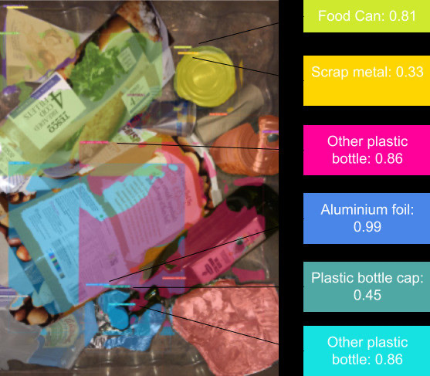

**Project 4B** (TA: Shyam Nandan Rai): **Resource Constrained Semantic Segmentation for Waste Sorting**

In this project the task is to perform semantic segmentation for a waste sorting task on an edge device with limited memory, in order to automate the sorting process. This task will require to investigate tiny semantic segmentation models and techniques such as knowledge distillation, pruning and quantization.